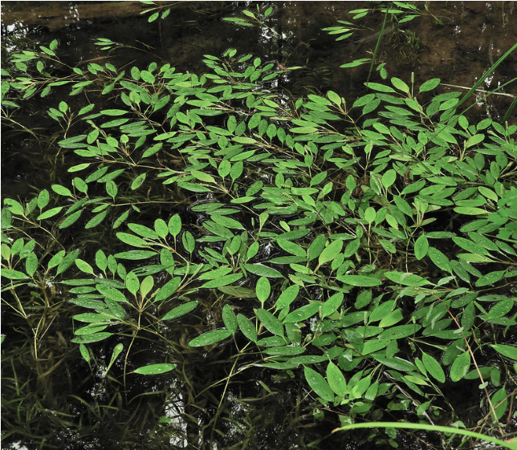

Don’t Feed the Weeds
Together we can keep our lakes beautiful

Did you know?
- Nutrients in a lake promote algae blooms and weed growth.
- Run-off from 1 acre of lawn can carry as much sediment and nutrients into a lake as 170 acres of forest.
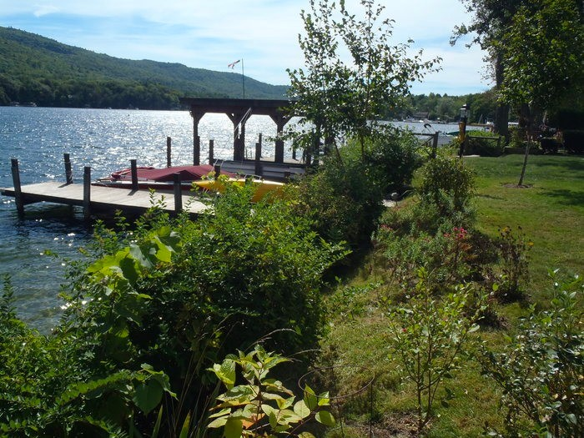
- Even a thin shoreline buffer can make a big difference!

Top 3 Benefits Of installing a vegetative buffer using native Adirondack vegetation
- Reduces shoreline erosion
- Creates filtration of run-off
- Prevents overpopulation of water fowl like geese

Contact the Hamilton County Soil and Water Conservation District to schedule an appointment for a FREE vegetation buffer consultation! | (518) 548-3991 hcswcd@frontiernet.net www.hcswcd.com

Maintain your septic system. Testing kits are available

Other Ways to Help!

Limit the use of fertilizers and pesticides and use phosphorus free fertilizer

Clean up pet waste to reduce polluted runoff

More Information
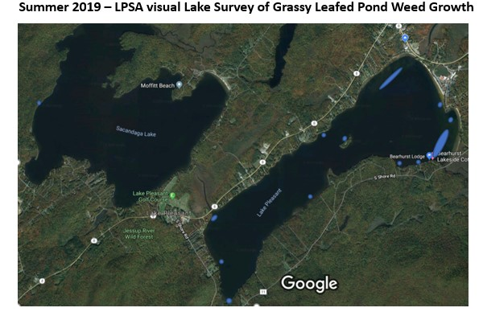
- LPSA members and many around the lake have taken notice of the recent weed expansion…more so in Lake Pleasant
- Grassy Leafed Pond Weed (GLP) is the most notable recent growth - it grows in ~4-10 ft of water depth and comes to surface in mid to late summer. Many patches around the lake…easiest to see on calm days.
- We have been able to keep non-native invasive weeds (e.g. milfoil) out of our lakes
so far. LPSA has been working hard with boat inspections, lake monitoring and education. LPSA is also building a fund for emergency remediation.
- LPSA has engaged with Hamilton County Soil and Water, APA and NYS DEC experts who have recommended community actions to minimize nutrient additions to the lake. Plants like nutrients and warm water. We can’t control the water temperature but we can limit nutrient additions. Agencies do not support nor recommend any broad scale weed removal of native plants.
- You are allowed to do localized hand weed pulling of less than 1000 square feet in front of your own property. See APA regulation HERE.
- Our Lakes are still quite clean and safe…LPSA has been actively monitoring our lakes. Nutrient limitation is our best defense against rapid expansion and reducing risks of hurting our property values.
- During a Lake Tour with the APA expert he commented that aerial photography of Lake Pleasant has shown significant shore line erosion over the past decades resulting in significant quantities (“dump trucks”) of nutrient rich soil entering the lake
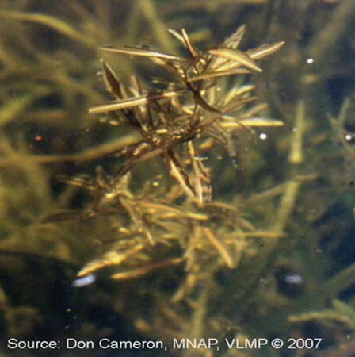
- According to a study; run-off from 1 acre of lawn can carry as much sediment (and nutrients) into a lake as 170 acres of forest.
- Shore line woody stalked buffers of about 6 feet in depth are shown to significantly reduce nutrient additions (by an order of magnitude)
- e.g. wild blueberry and wild azaleas (pinksters)
- Geese deterrent as well
- Hamilton County Soil and Water provides free individual site consultations to give you ideas for your shore line. More Detailed plans can be purchased.
- Older and ineffective septic systems are another major source for nutrient additions. You can test this yourself with a simple dye test, which you flush down your toilet. Testing kits are available at the Hamilton County Soil and Water Conservation District office.

